Job Application Tracking System

1 INTRODUTION

* 1. Overview

Create a CRM Applications which helps the applicant to track the No.of jobs he applied and helps him to find the jobs posted by the various recruiters, find the best attributes to be involved to run the process in a smooth way and easily to track.

* 1. Purpose

Resume screening: An ATS can automatically scan and filter resumes based on keywords and qualifications specified by the employer.

Candidate communication: An ATS can send automated emails to candidates to inform them about the status of their application, schedule interviews, and request additional information.

Interview scheduling: An ATS can integrate with a calendar system to schedule interviews, send reminders to candidates, and update the hiring team.

Compliance management: An ATS can help ensure that employers comply with legal and regulatory

requirements, such as equal opportunity

employment laws.

# Problem Definition & Design Thinking

# 2.1 Empathy Map

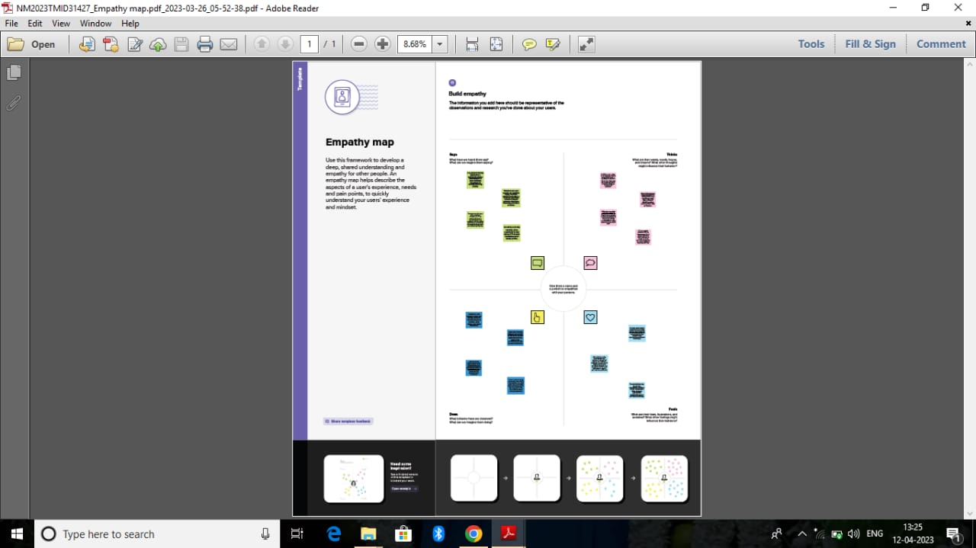

2.2 Ideation & Brainstorming Map

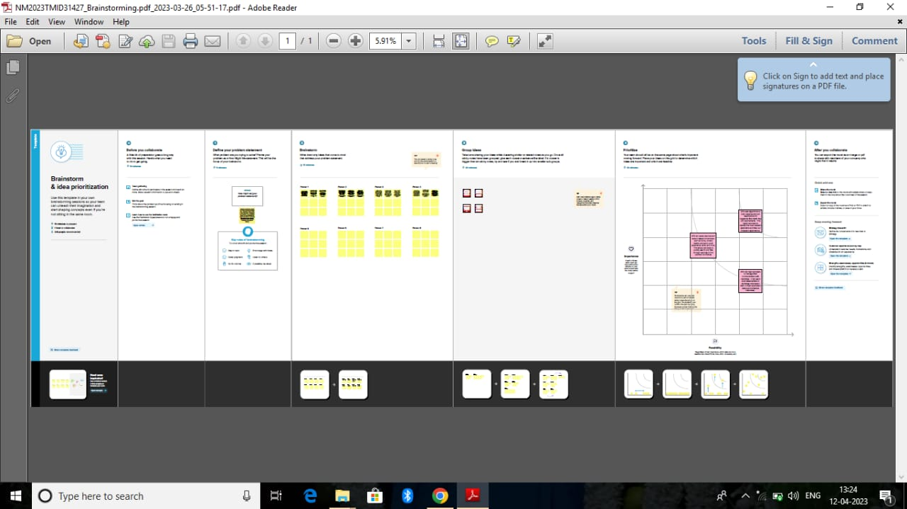

1. RESULT
   1. Data Model:

|  |  |
| --- | --- |
| Object name | Fields in the object |
| Job  Job Application | |  |  | | --- | --- | | Field label | Data type | | Description | Textarea | | Jobtittle | Text | | Field label | Data type | | location  Recriuter | Text  Mesterdetail |  | |
| Tab | |  |  |  | | --- | --- | --- | | Field label | Data type |  | | Recriuter | Mester detail | | Job tittle | Text |  | |
| Candidate | |  |  | | --- | --- | | Field label | Data type | | Description | Text area | | Location | Text | |
| Recruiter | |  |  | | --- | --- | | Field label | Data type | | Job tittle | Text | | promotion | Master detail | |

* 1. Activity & Screenshot

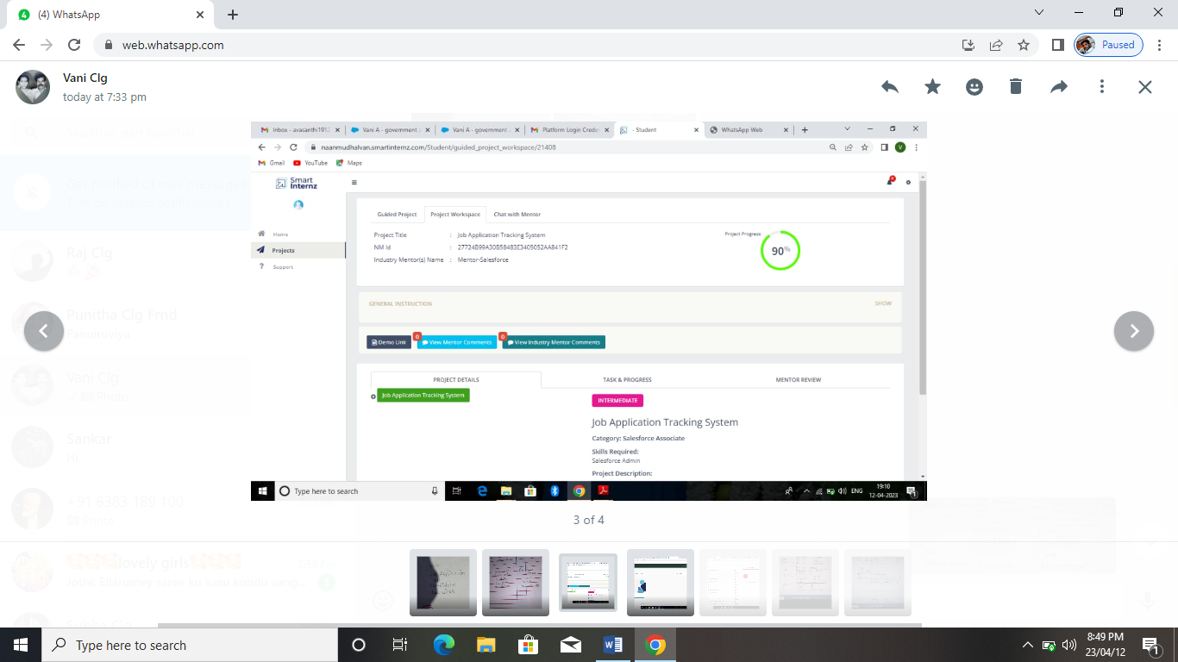

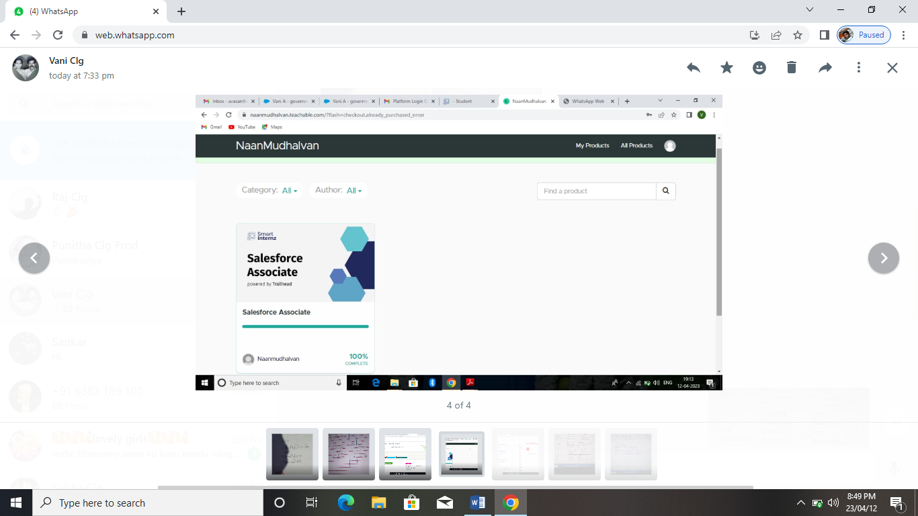

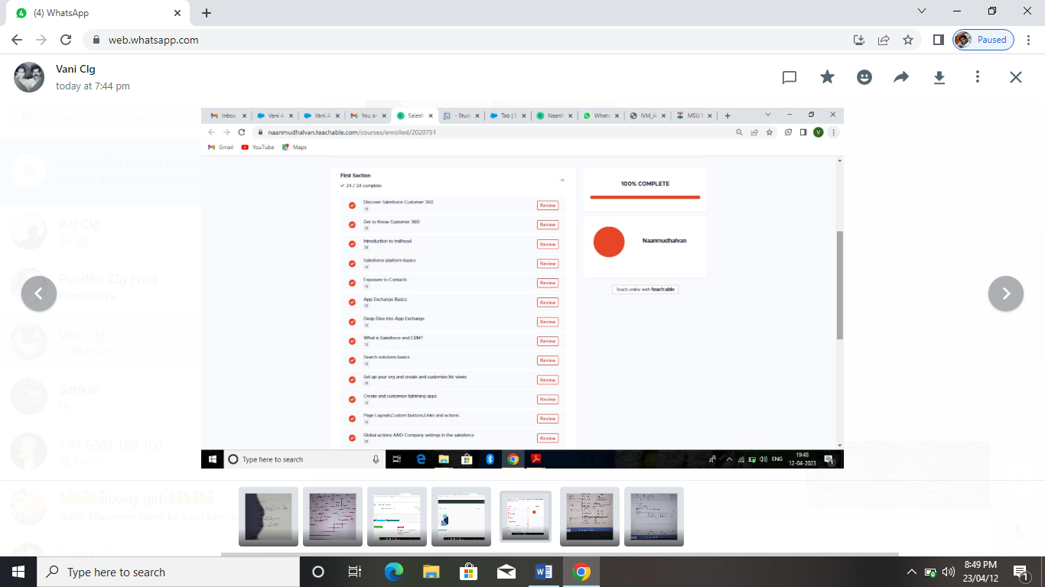

4. Trallhead Profile Public URL

Team lead - <http://trailblazer.me/id/vania62>

Team Member 1 - <http://trailblazer.me/id/sushmitha47>

Team Member 2 - <https://trailblazer.me/id/ranjini2002>

Team Member 3 - <https://trailblazer.me/id/sangeetha38>

5. ADVANTAGES & DISADVANTAGE

There are several advantages to using a job application tracking system (ATS) for managing the hiring process:

Improved efficiency: An ATS can automate many aspects of the hiring process, such as resume screening, interview scheduling, and candidate communication. This saves time and reduces the workload for recruiters and hiring managers, allowing them to focus on more strategic aspects of the hiring process.

Better candidate experience: An ATS can provide candidates with a more streamlined and transparent hiring process. Candidates can receive automated updates on the status of their application and easily schedule interviews, improving their overall experience.

Increased accuracy: An ATS can reduce human error in the hiring process by automating many of the administrative tasks. For example, an ATS can ensure that all candidates are evaluated based on the same criteria and that all necessary documentation is collected and stored.

Improved data management: An ATS can help recruiters and hiring managers better manage and analyze data related to the hiring process. This can provide valuable insights into the effectiveness of different recruiting strategies and help identify areas for improvement.

Compliance management: An ATS can help ensure that employers comply with legal and regulatory requirements, such as equal opportunity employment laws. An ATS can also track the status of background checks, drug tests, and other pre-employment screenings to ensure that all necessary requirements are met.

potential disadvantages to consider:

Cost: Implementing and maintaining an ATS can be expensive, particularly for small businesses or organizations with limited resources.

Technical issues: An ATS is a software system, and as such, it can experience technical issues or glitches. This can result in lost data or a disrupted hiring process.

Over-reliance on automation: While automation can improve efficiency, it can also lead to a lack of personal touch in the hiring process. Candidates may feel like they are interacting with a machine rather than a human, which can negatively impact the candidate experience.

Keyword-based screening: Some ATS systems rely heavily on keyword-based resume screening, which can result in qualified candidates being overlooked if they don't use the exact keywords specified in the job posting.

Bias: While an ATS can help reduce bias in the hiring process, it can also introduce new biases if the system is not designed and configured properly. For example, if the system is not trained to recognize a diverse range of qualifications and experiences, it may inadvertently screen out candidates from underrepresented groups.

6. APPLICATIONS

job application tracking system (ATS) can be used in a variety of ways to streamline and manage the hiring process. Here are some common applications of an ATS:

Resume screening: An ATS can automatically scan resumes and filter out unqualified candidates based on specific criteria, such as skills, experience, and education.

Candidate communication: An ATS can send automated emails to candidates to inform them about the status of their application, request additional information, and schedule interviews.

Interview scheduling: An ATS can integrate with a calendar system to schedule interviews, send reminders to candidates and update the hiring team.

Candidate database management: An ATS can store candidate information and resumes in a centralized database, making it easy to search and find candidates for future job openings.

Applicant analytics: An ATS can provide data and analytics on the hiring process, such as the number of applications received, the percentage of applicants who moved on to the next stage, and the time taken to hire.

Compliance management: An ATS can help ensure that employers comply with legal and regulatory requirements, such as equal opportunity employment laws, by tracking and reporting on candidate data.

Onboarding: An ATS can integrate with other HR systems, such as payroll and benefits management, to streamline the onboarding process for new hires.

7. CONCLUSION

a job application tracking system (ATS) can be a valuable tool for organizations looking to streamline and manage the hiring process. An ATS can automate many aspects of the hiring process, such as resume screening and candidate communication, saving time and resources for recruiters and hiring managers. Additionally, an ATS can provide data and analytics on the hiring process, allowing organizations to identify areas for improvement and make data-driven decisions. However, it's important to carefully consider the potential advantages and disadvantages of an ATS before implementing one, taking into account factors such as cost, technical issues, and potential biases. Overall, an ATS can help organizations improve efficiency, provide a better candidate experience, and ensure compliance with legal and regulatory requirements.

8. FUTURE SCOPE

The future of job application tracking systems (ATS) is likely to involve continued innovation and technological advancements. Here are some potential trends that may shape the future of ATS:

Artificial intelligence (AI) and machine learning: ATSs are already using AI and machine learning algorithms to improve resume screening and candidate matching. In the future, these technologies may become even more sophisticated, allowing for more accurate and efficient candidate evaluation.

Mobile optimization: As mobile devices become more ubiquitous, ATSs may become more optimized for mobile use. This could include mobile-friendly job applications and resume submissions, as well as mobile-first candidate communication.

Personalization: While ATSs can streamline the hiring process, they can also feel impersonal to candidates. In the future, ATSs may incorporate more personalization features, such as customized candidate communication and personalized job recommendations.

Integration with other HR systems: ATSs may become more integrated with other HR systems, such as payroll and benefits management. This could allow for a more seamless onboarding process for new hires.

Diversity and inclusion: As organizations focus more on diversity and inclusion, ATSs may become more specialized in identifying and eliminating potential biases in the hiring process. This could include the development of specialized algorithms and machine learning models that are specifically designed to identify and remove bias.